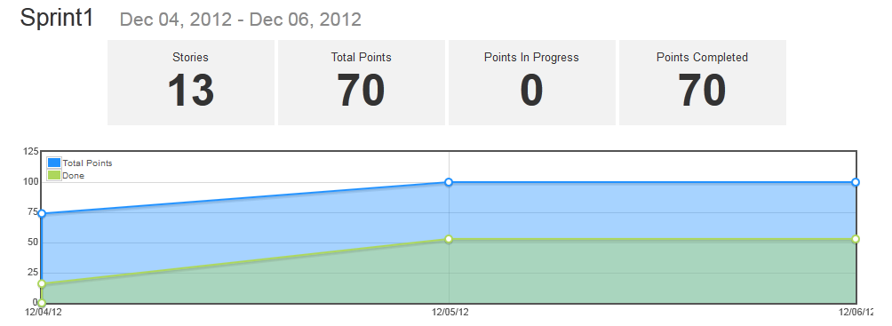

Example of a burndown-chart from a concluded sprint, in this case we forgot to put the last stories to status: Done before the sprint was done, so that wasn’t calculated properly, resulting in the green field not reaching the top.

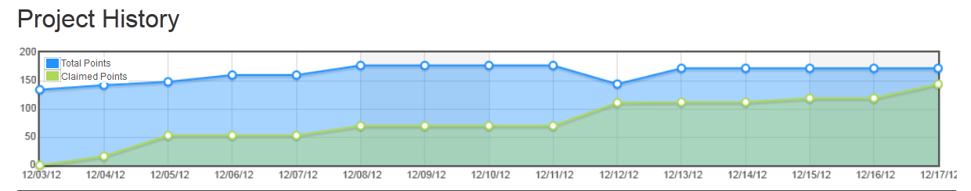

This is our burndown-chart for the entire project duration.